**Assignment 2:**

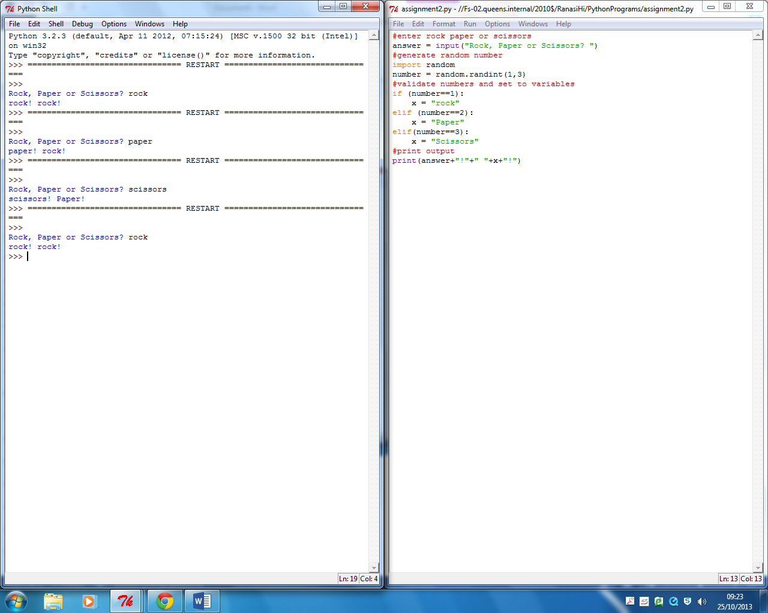**Challenge two:**

1. Start
2. Ask for “rock “, “paper” or “scissors”
3. Computer generates number
4. Both computer and users inputs are printed

**Challenge three:**

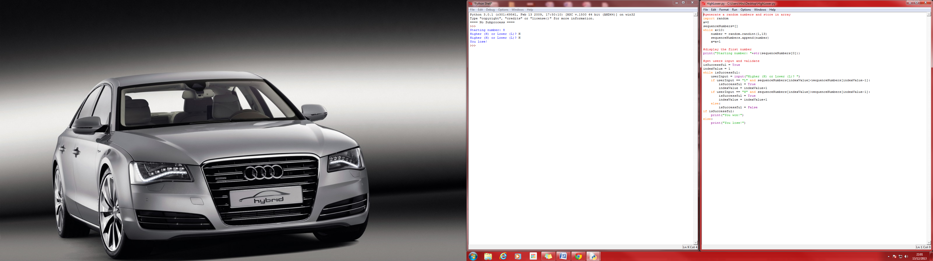

1. Computer predetermines a sequence of 13 random numbers.
2. The computer will print the first random number.
3. The user will be expected to type H for higher and L for lower.
4. If the user is right the game will progress but if the user is wrong the game will end followed by a text saying “You lose!”



1. The computer will ask the user to enter two test scores.
2. The computer will find the average score.
3. The computer will then store the first test score, the second test score and the average test score onto a list.
4. The computer will then find the grade for the first test score.
5. The computer will then find the grade for the second test score.
6. The computer will then find the grade for the average score.
7. All results are printed.